Kevin Keating
Kkeating3@ivytech.edu
PhysicsII-(PHYS102-11R-B1-201320)

Experiment: Mirrors
Introduction:

Procedure:
Data and Observations:
Converging Mirror:
Converging Mirror
p | q | f | M | image
30 | 15 | 10 | -0.5 | real
25 | 16.6 | 10 | -0.66 | real
20 | 20 | 10 | -1 | real
15 | 30 | 10 | -2 | real
10 | ∞ | 10 | -100 | real
5 | -10 | 10 | 2 | virtual

p=30.0
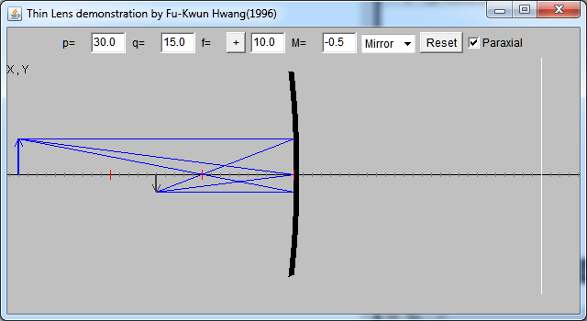
p=25.0
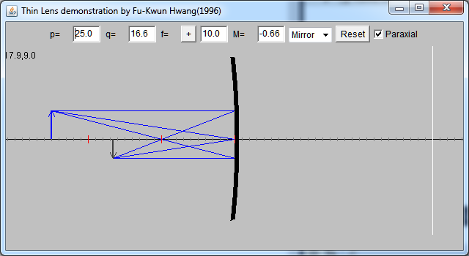

p=20.0
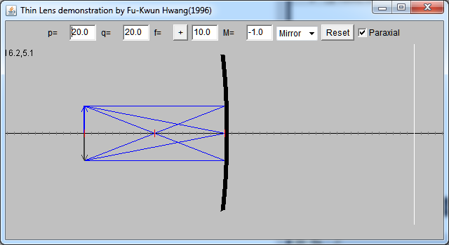
p=15.0
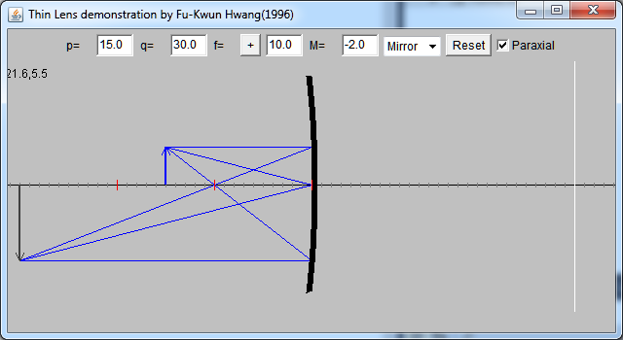

p=10.0
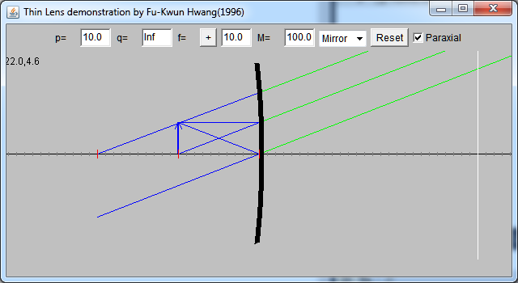

p= 5.0
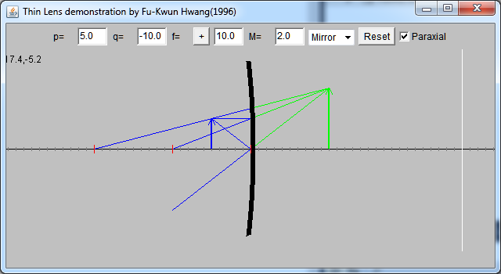
Diverging Mirror
Diverging Mirror
p | q | f | M | image
30 | -7.5 | 10 | 0.25 | virtual
25 | -7.1 | 10 | 0.28 | virtual
20 | -0.66 | 10 | 0.33 | virtual
15 | -6 | 10 | 0.4 | virtual
10 | -5 | 10 | 0.5 | virtual
5 | -3.3 | 10 | 0.66 | virtual

p= 30.0
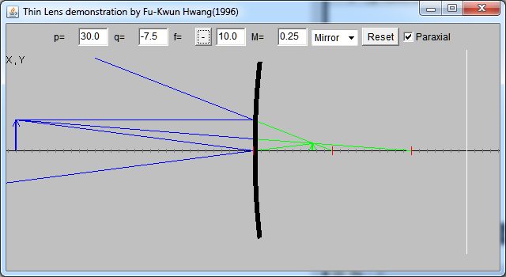
p= 25.0
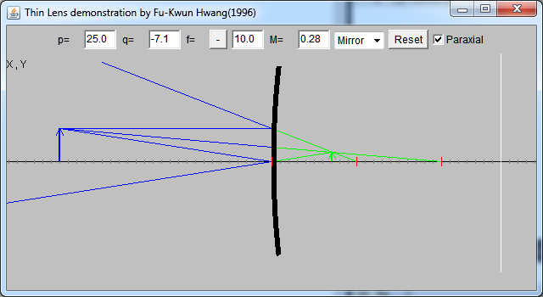
p= 20.0
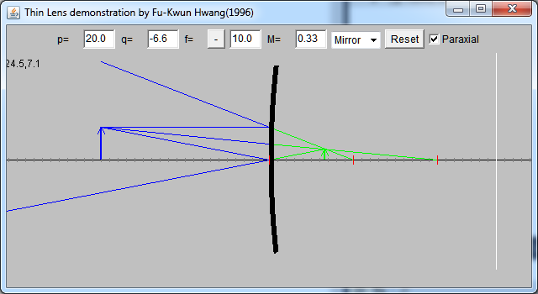
p= 15.0
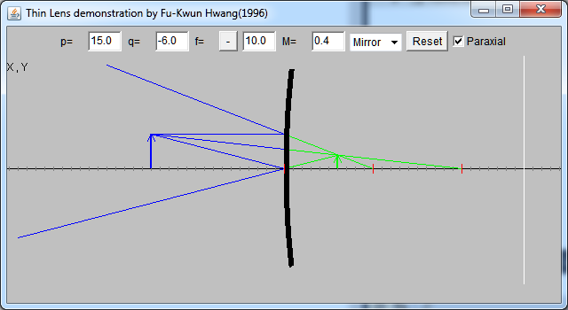
p= 10.0
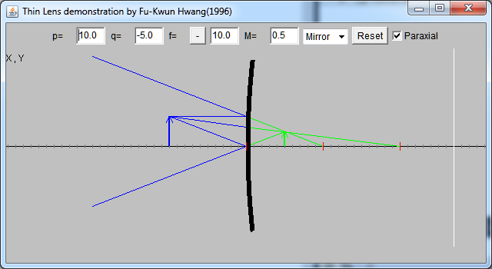
p= 5.0
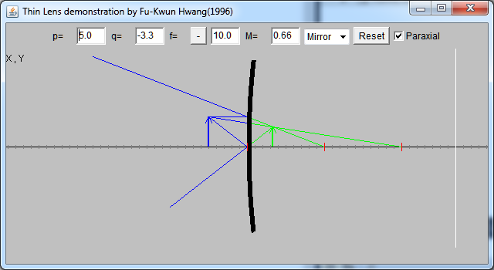

Conclusions:

